Task on S3

- Create an S3 bucket and upload some objects to S3.
Go to s3 in aws
Then create s3 bucket

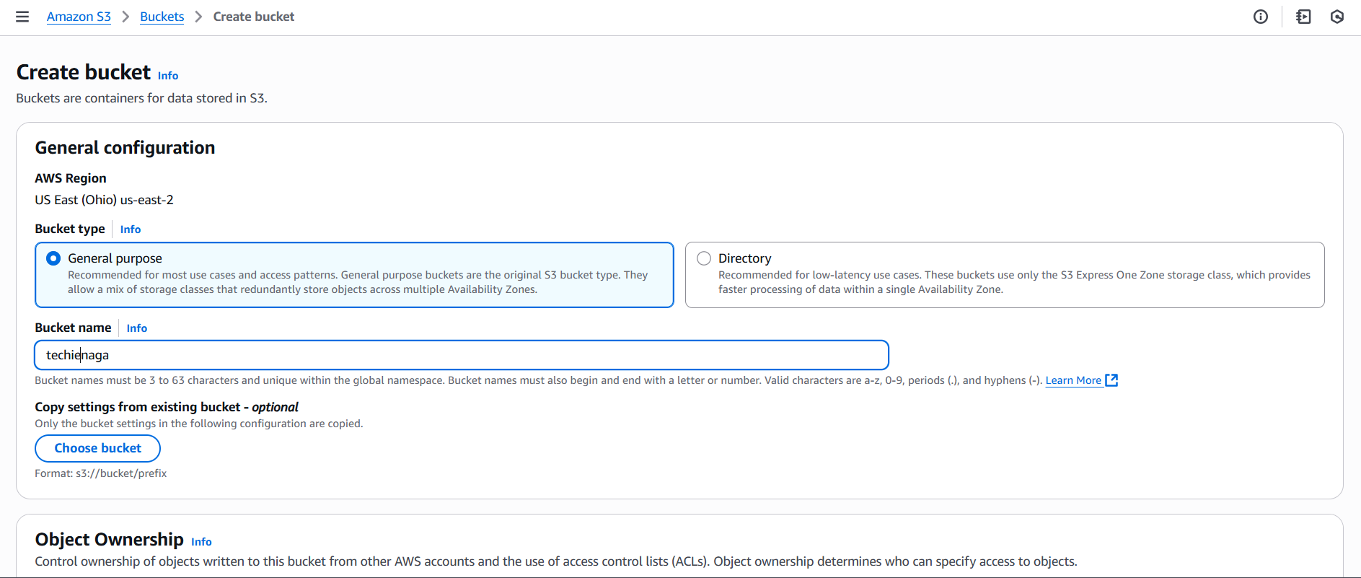

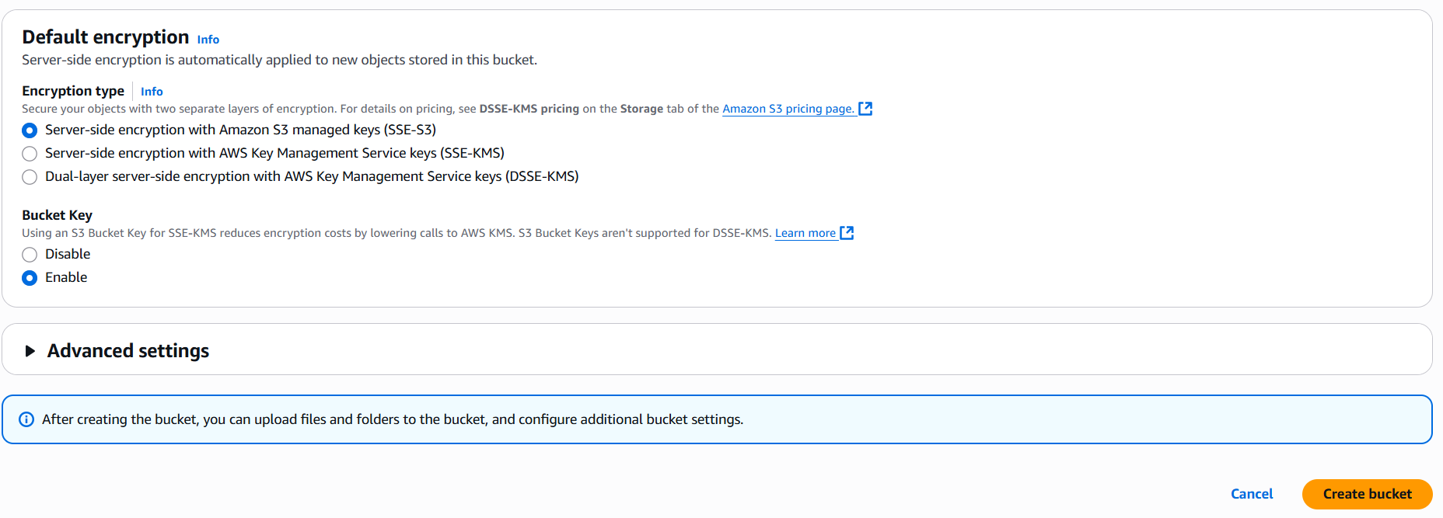
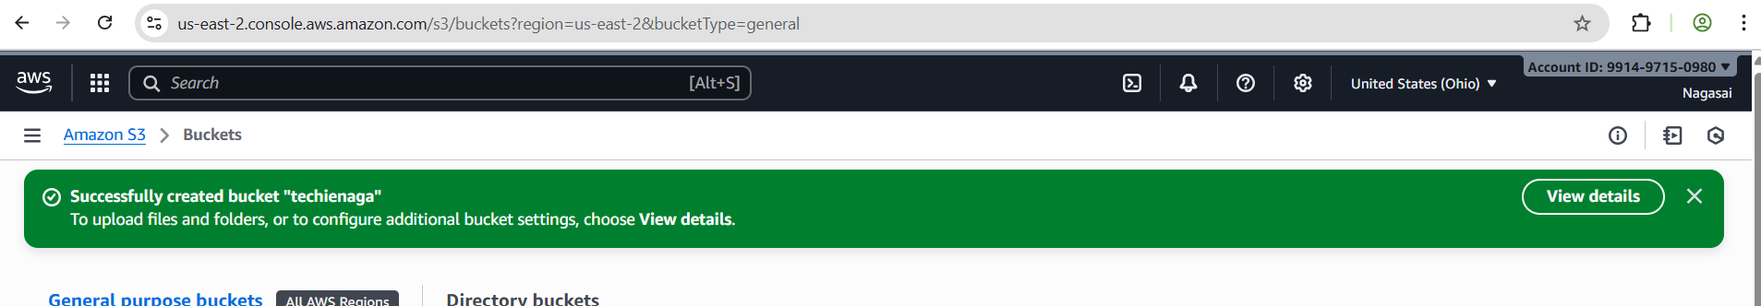

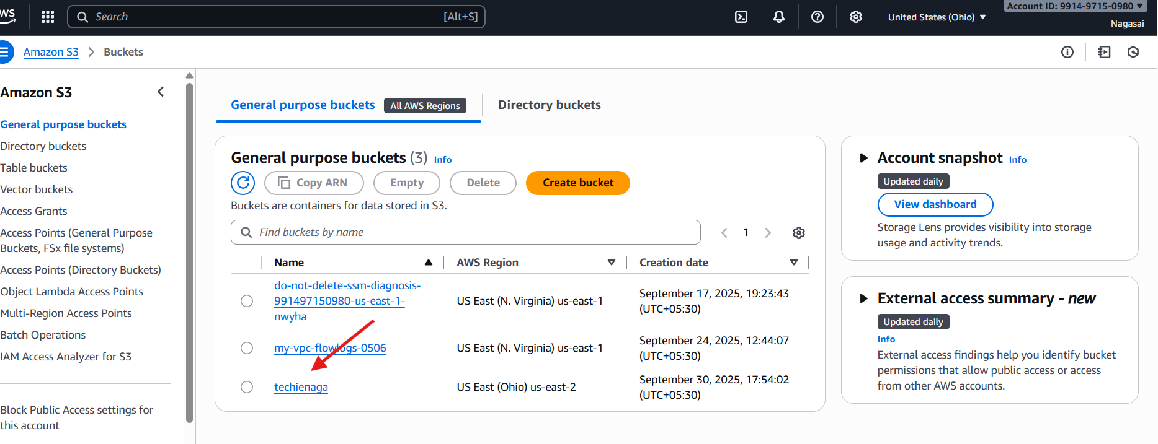
Add files –select the files
Select the permission to grant access the files public
The file is successfully uploaded in the s3 bucket.

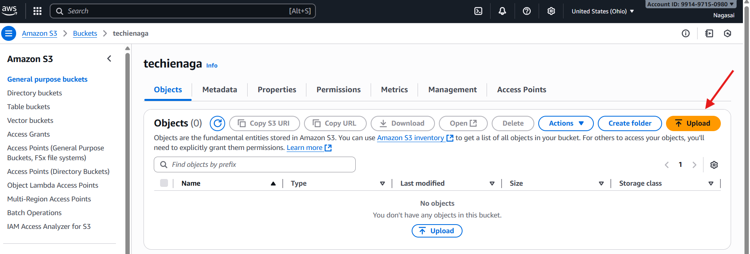
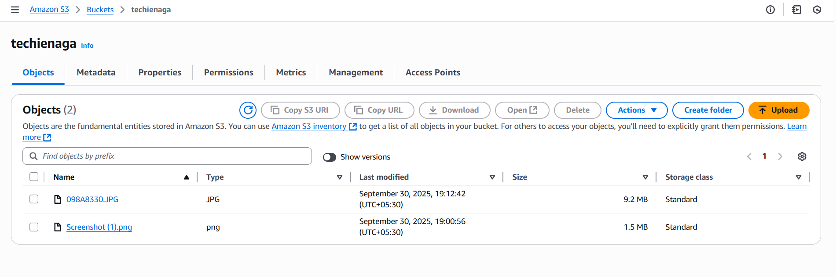
- Deploy a static website in the S3 bucket.
Go to your s3 bucket
Properties -- enable static website – index.html
Upload one html file and make sure your bucket has public acess if not ACLs enable in s3 configuration.
Upload index.html and error.html file to lauch an static website

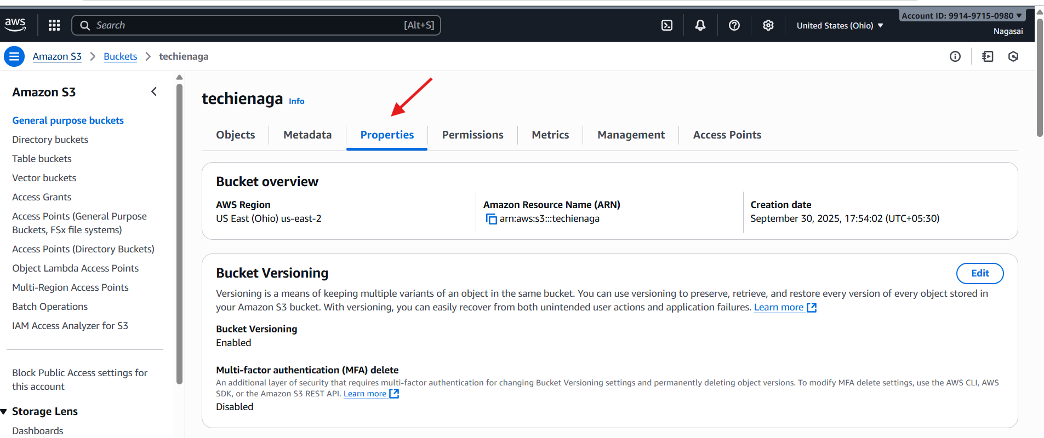
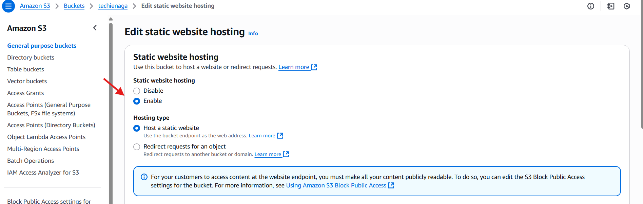
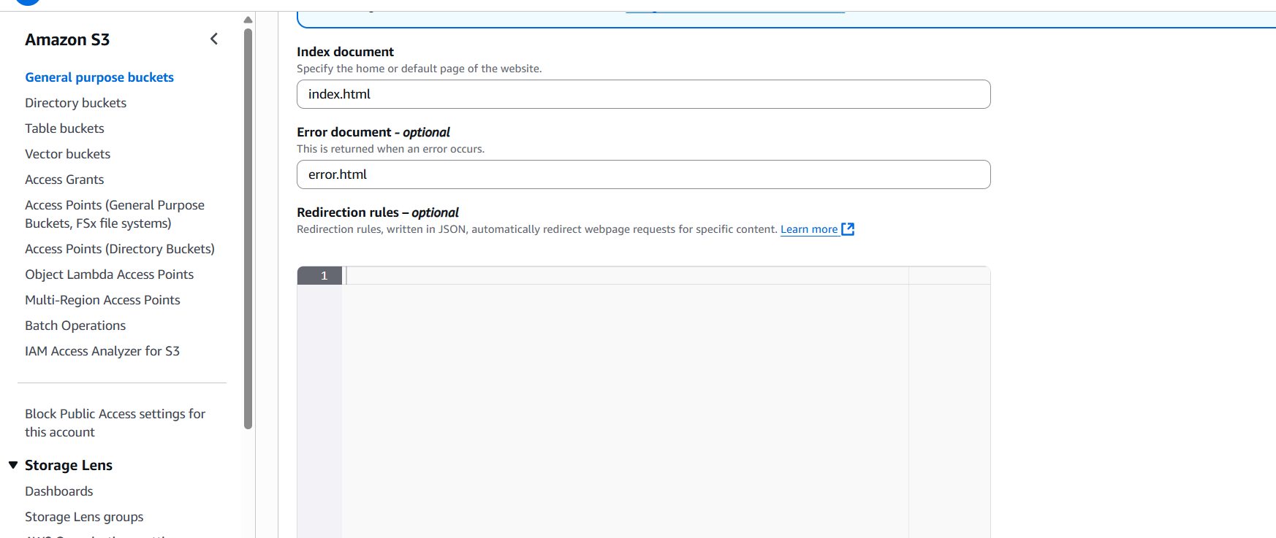
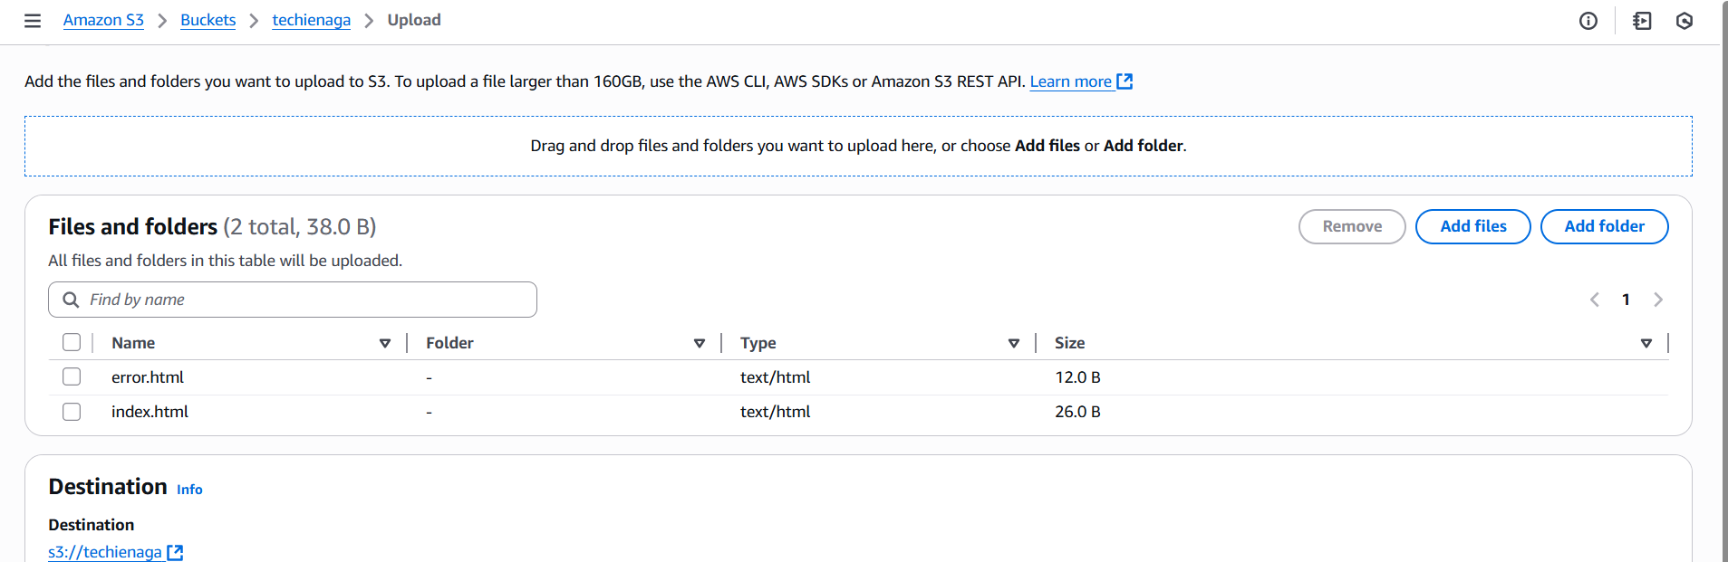
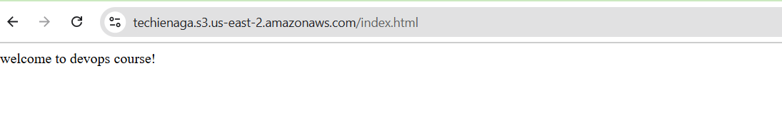
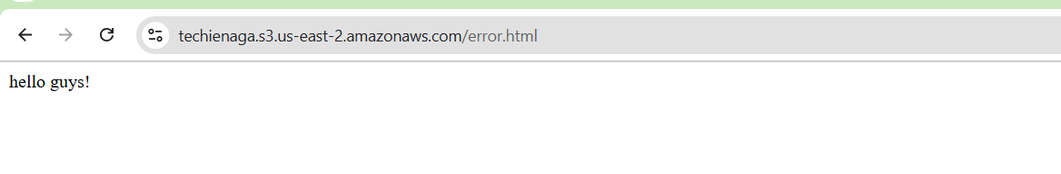
- Enable cross-region replication on S3 buckets.
Create 2 buckets in two different region
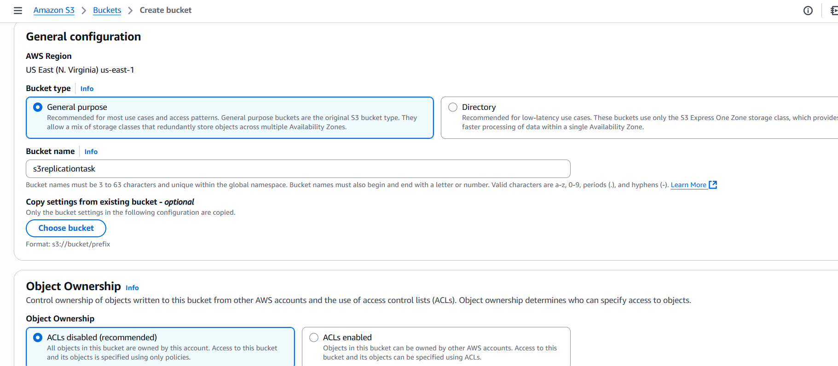
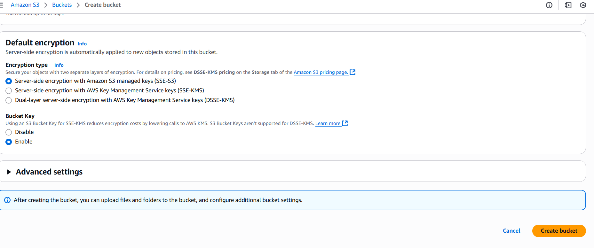
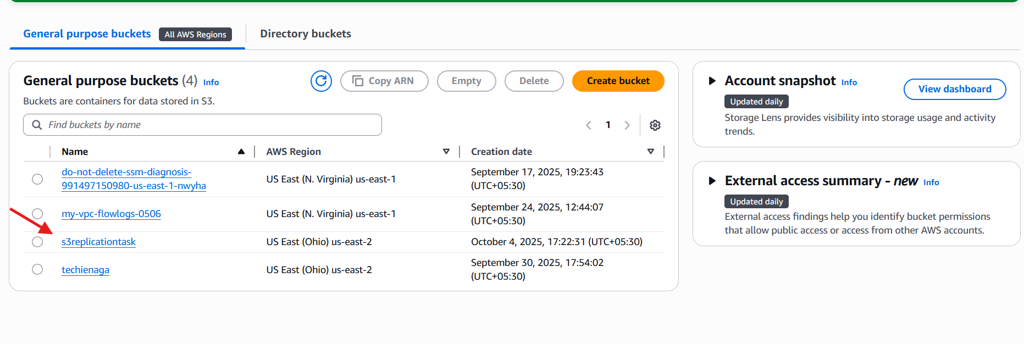
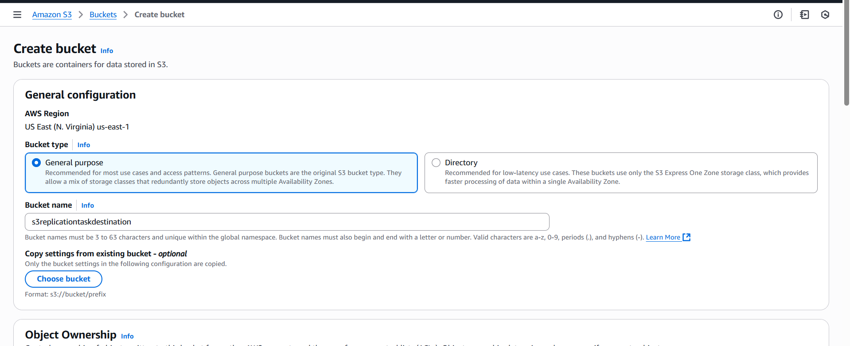
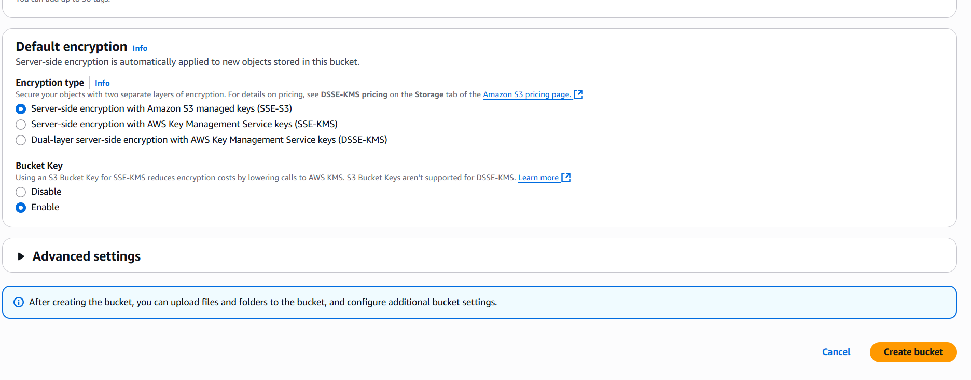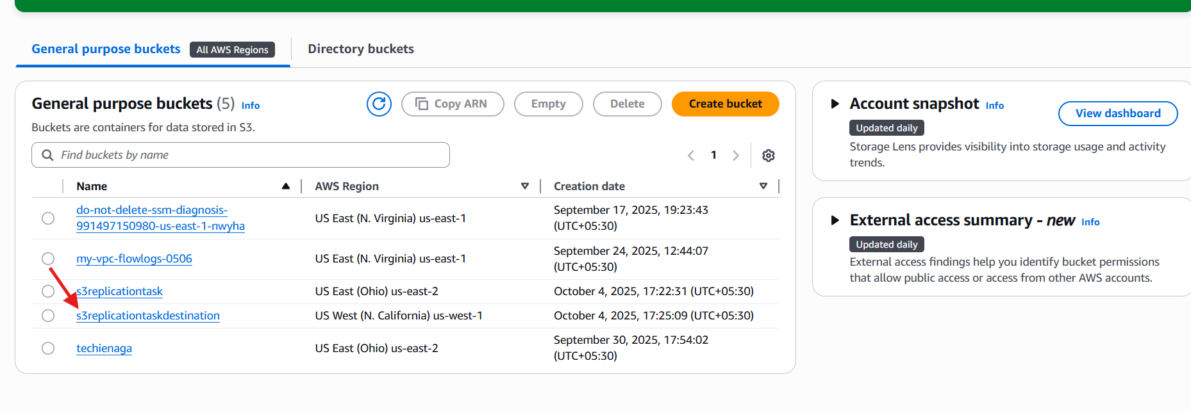

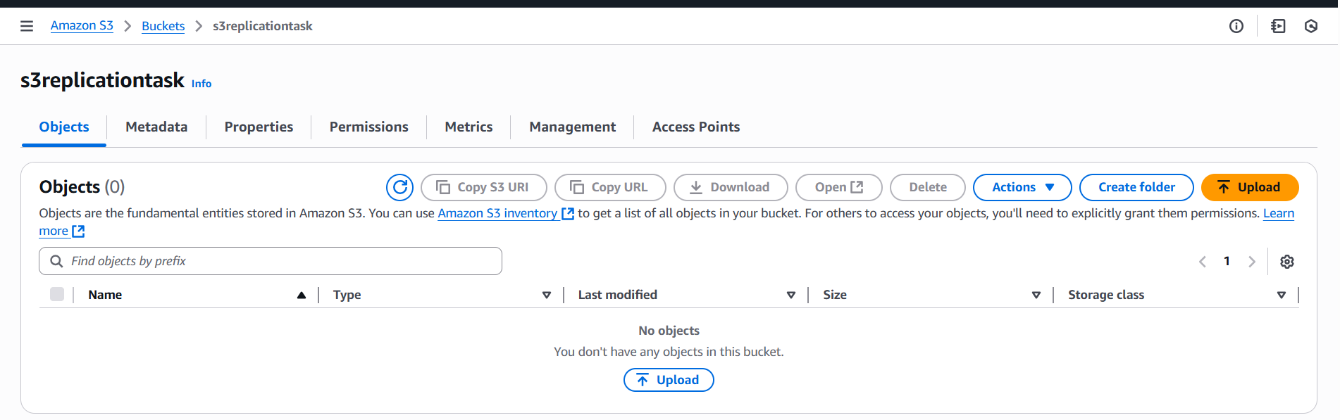

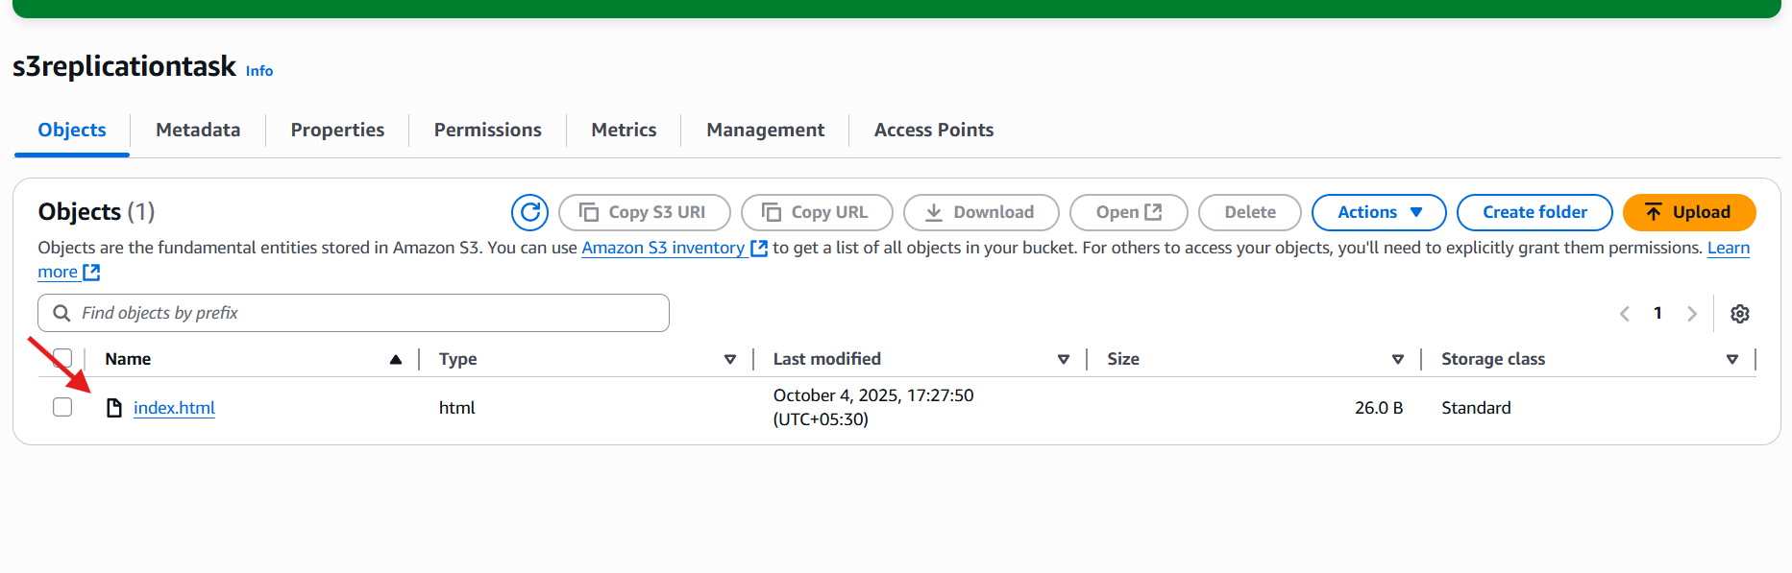
Go to management section and create replication rule and choose a bucket in another region.
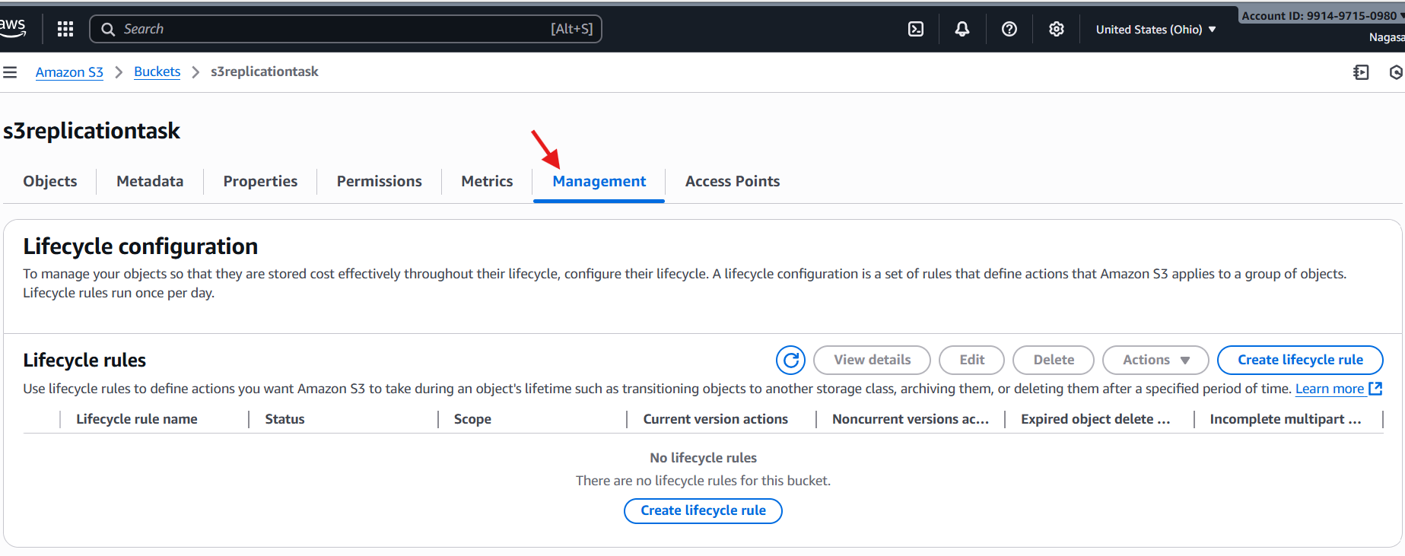
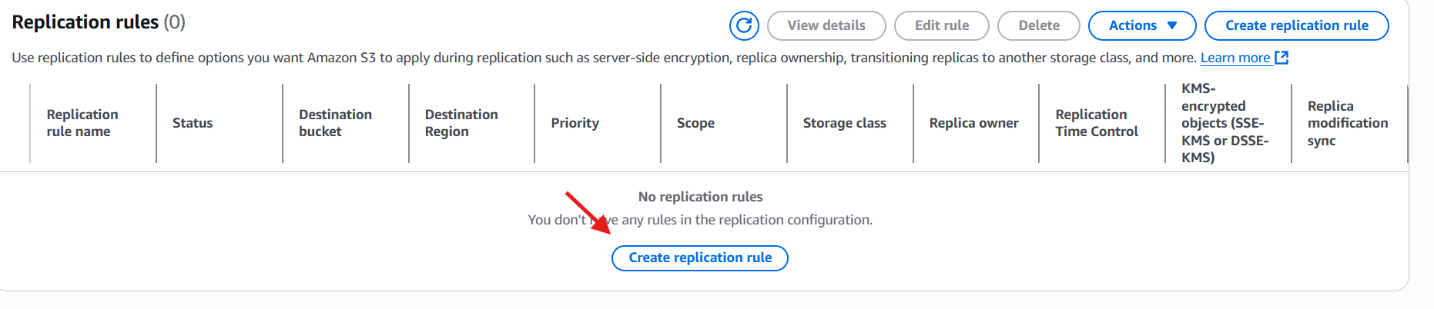
In replication rule choose a bucket
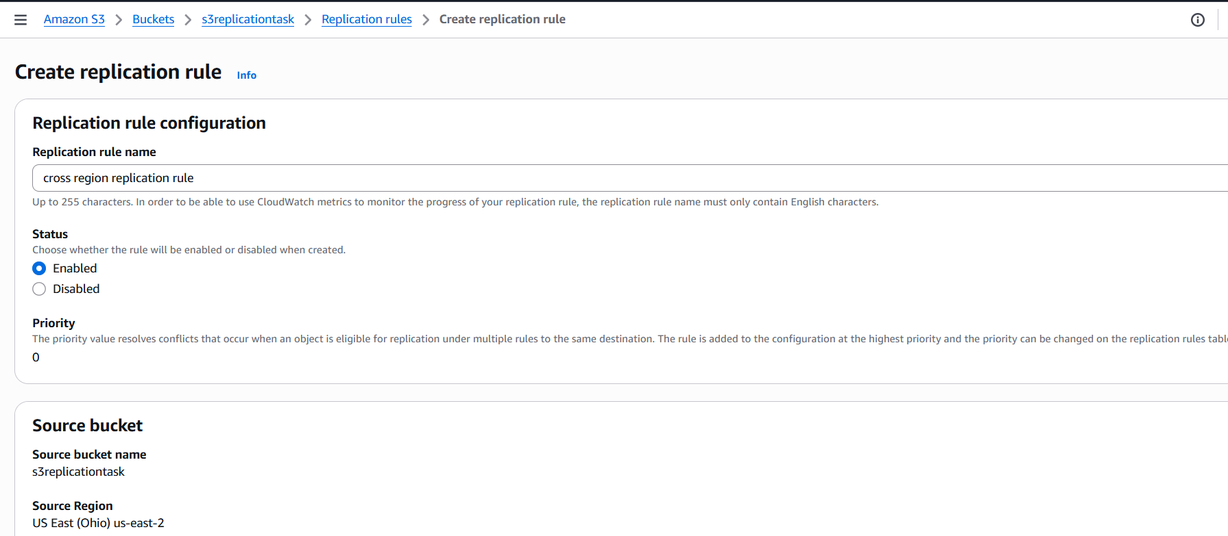
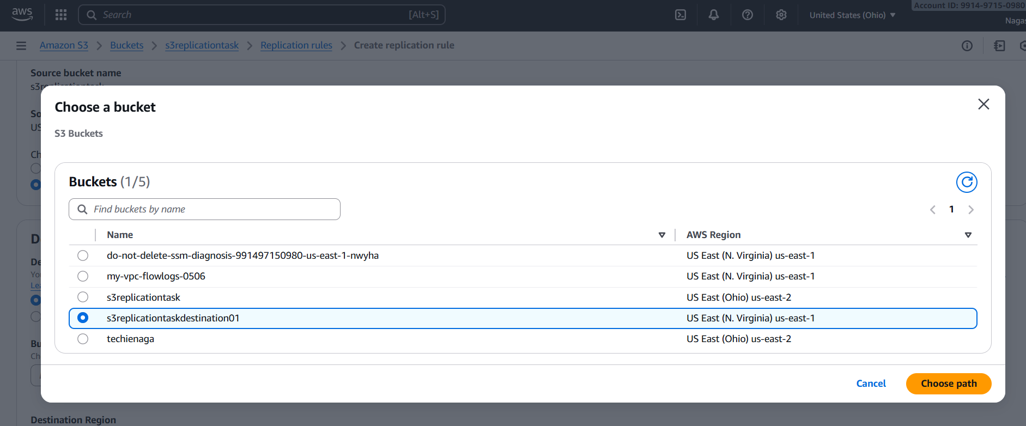
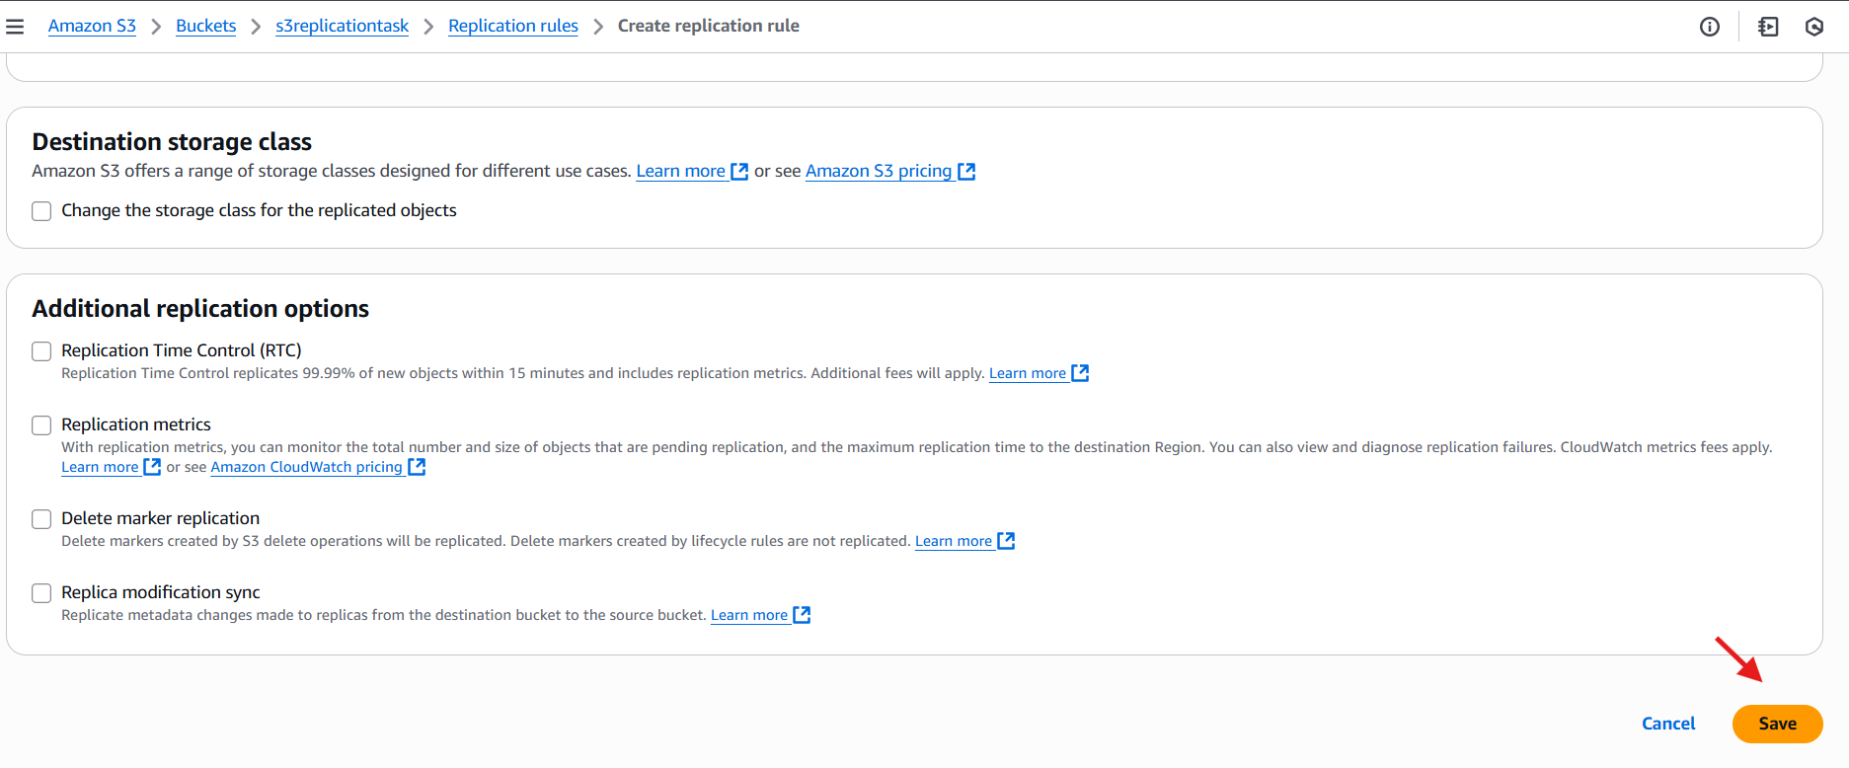

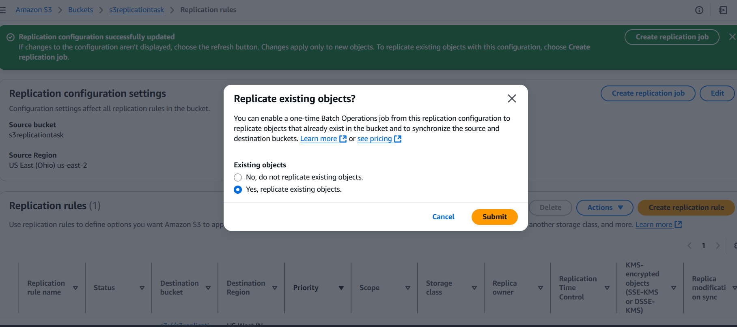
And then finally see a object in another region.
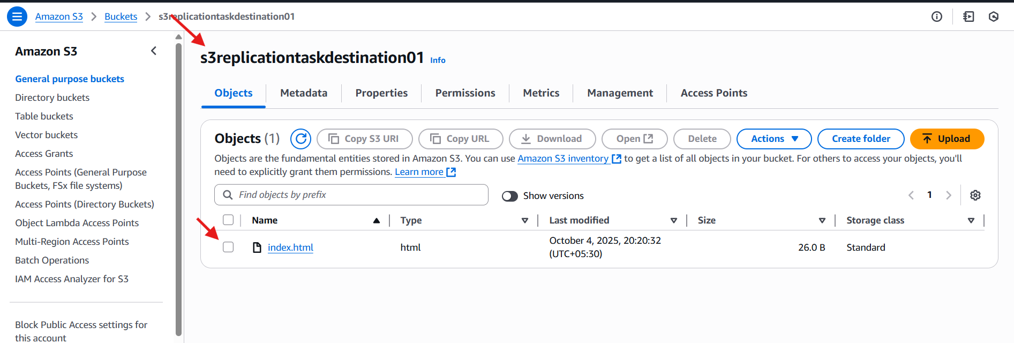

- Configure a bucket policy so only the Admin user can see the objects of the S3 bucket.
Go to aws s3 bucket
Properties copy the arn
Got browser search for aws policy generator
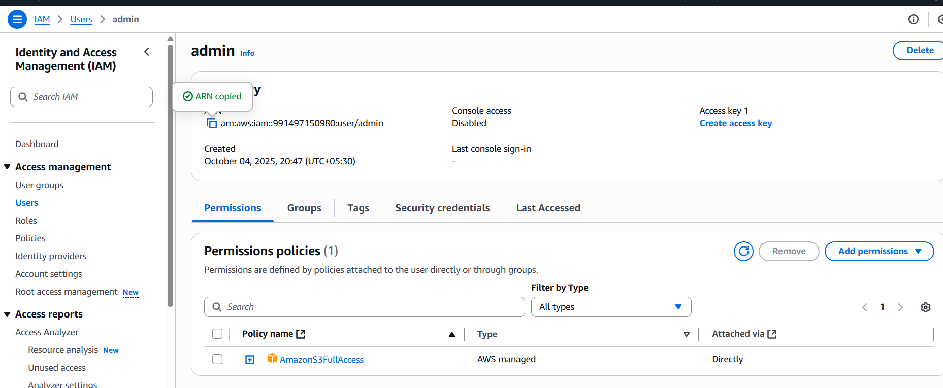
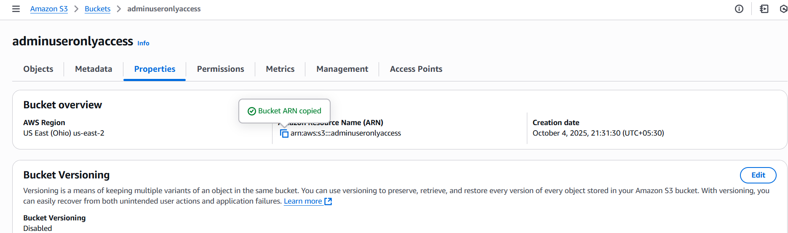
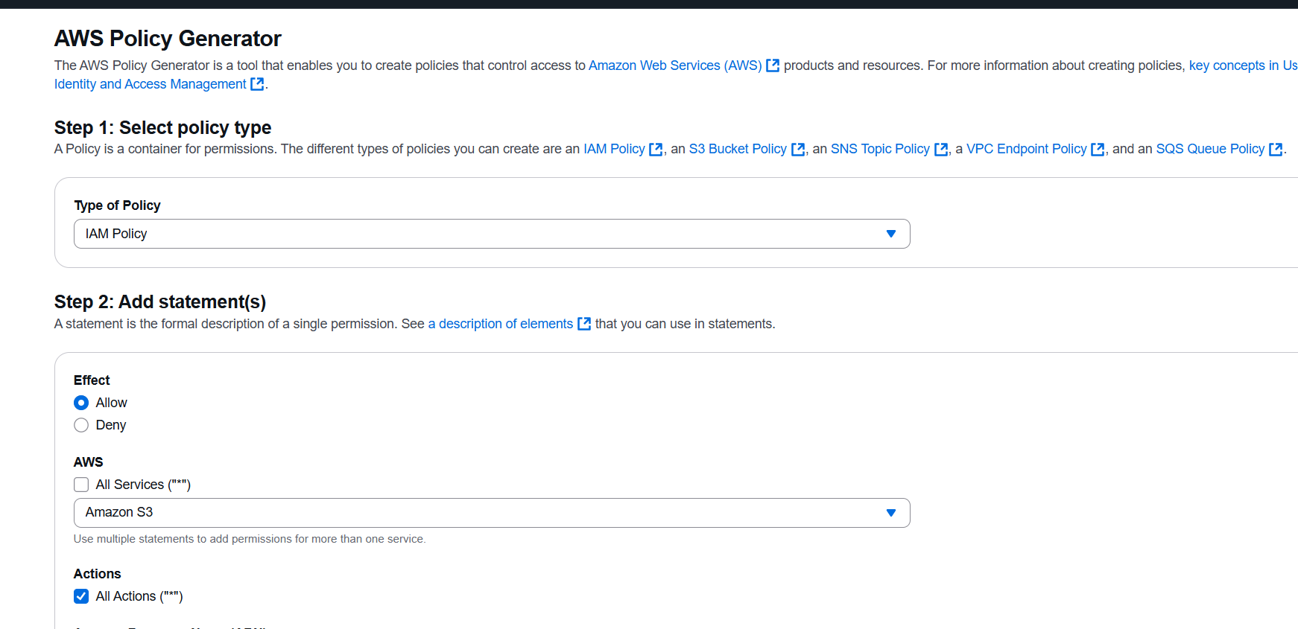
Select the service and all actions
Give the arn of the bucket
Add statement – generate policy – copy the policy .

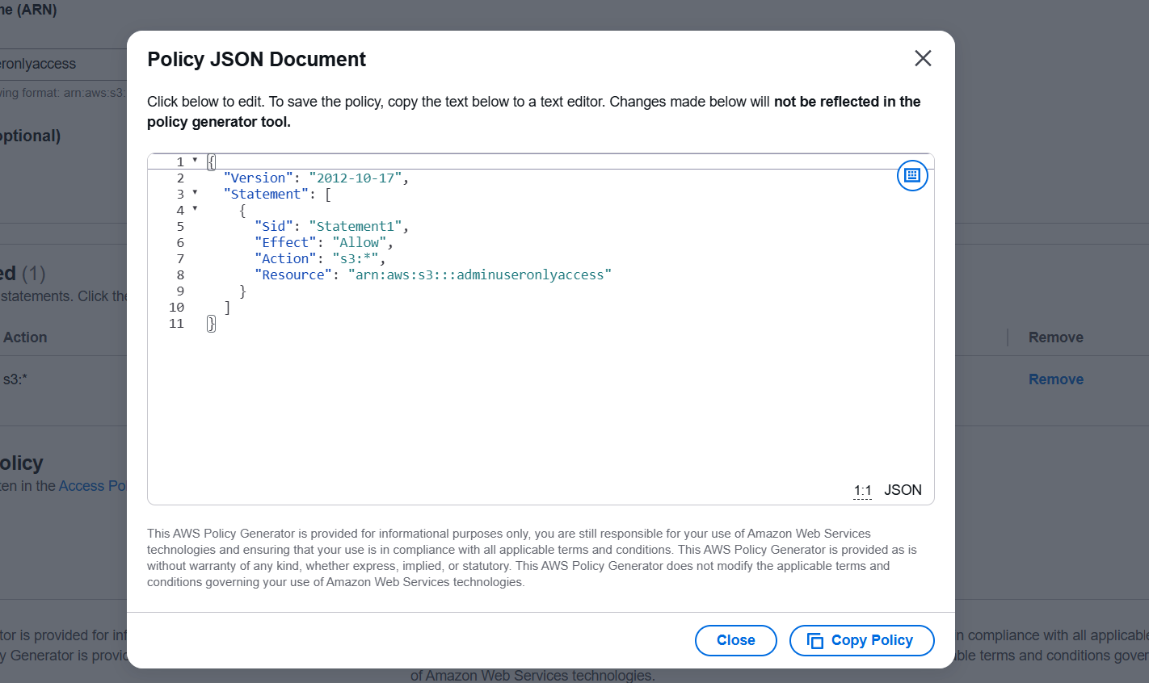
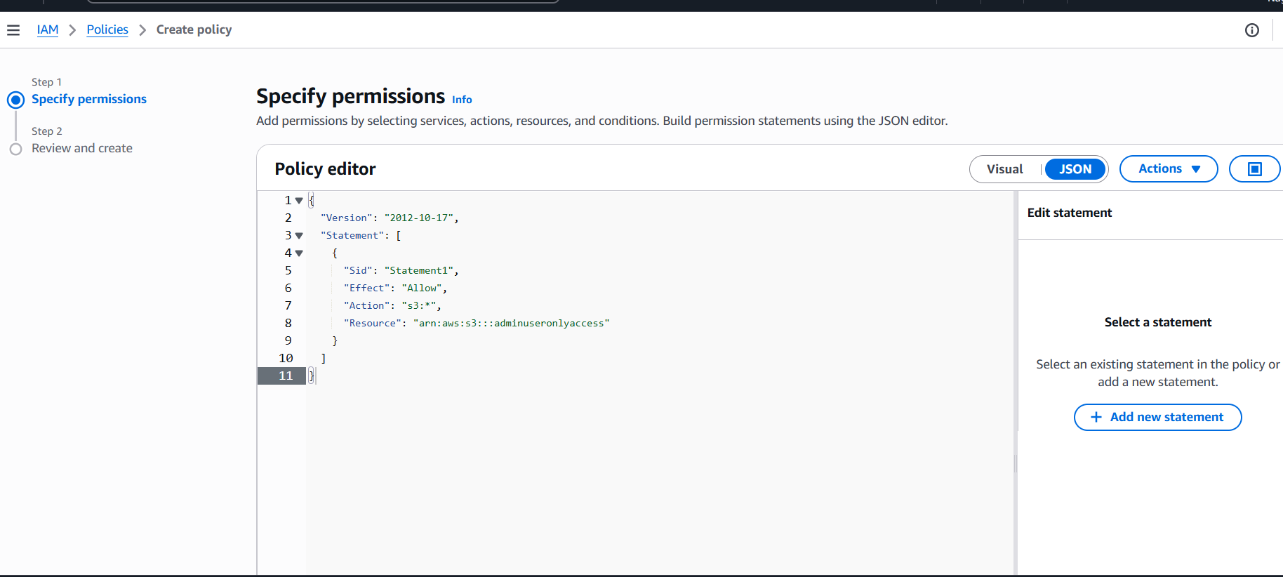
- Set up lifecycle policies to automatically transition or delete objects based on specific criteria.
Go to s3 bucket – management --- create life cyclerule
Give the life cycle name and specify the criteria from the options life cycle rule actions

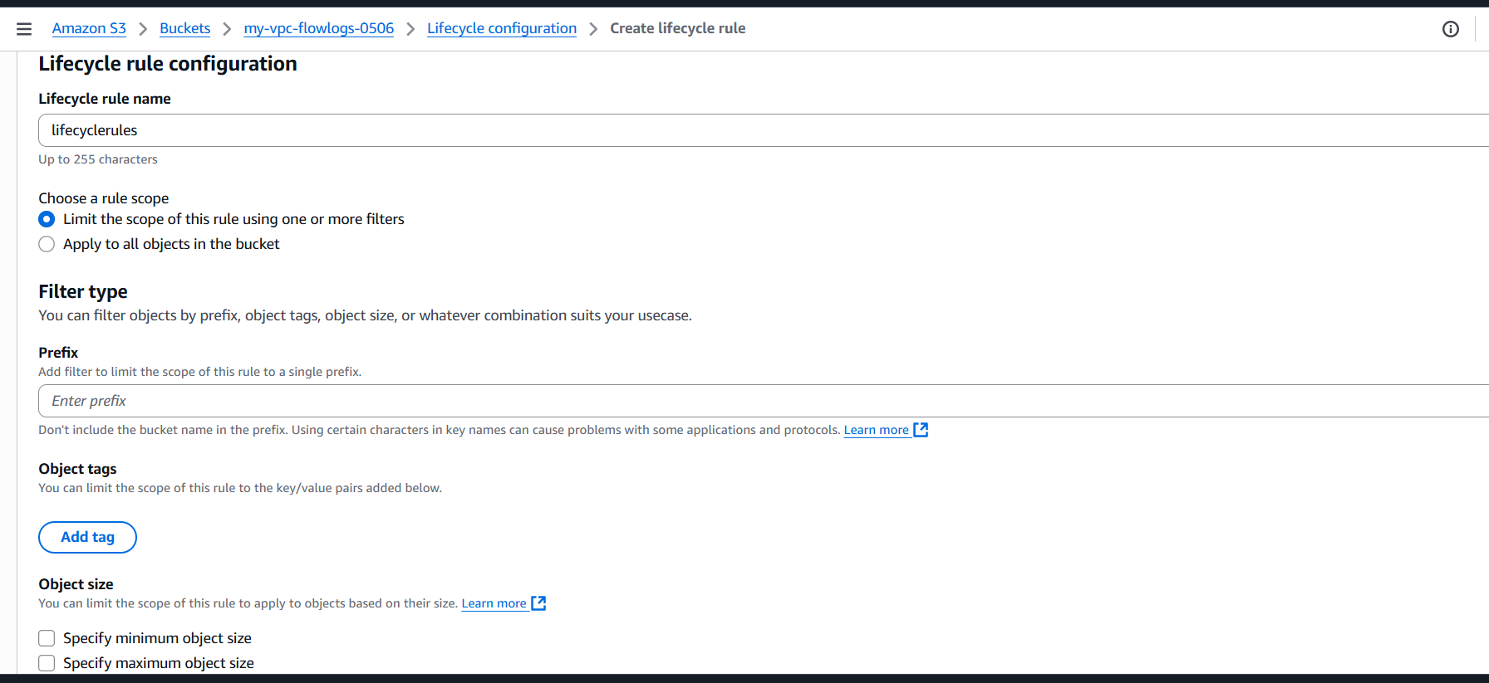
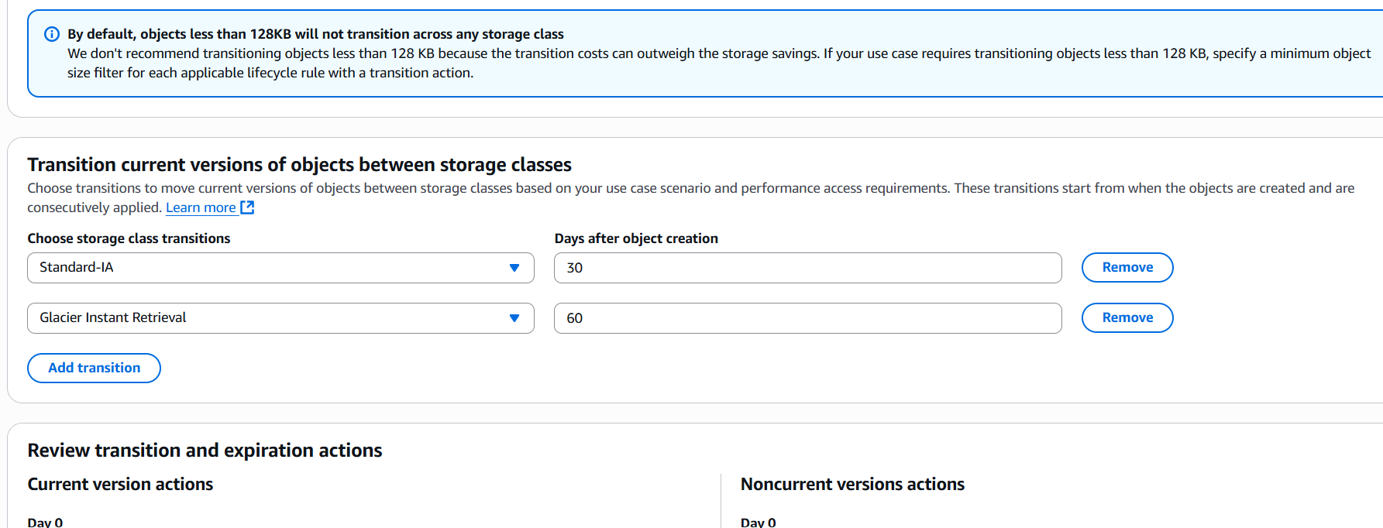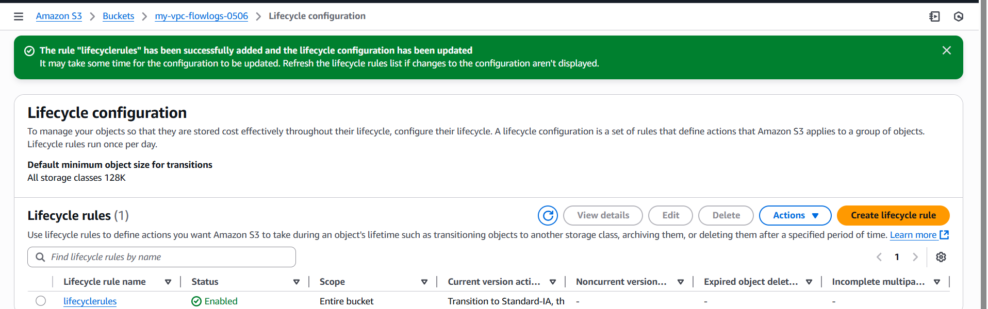
- Push some objects to S3 using the AWS CLI.
aws s3 ls view bucket list
[ec2-user@ip-172-31-0-104 ~]$ echo "test" > test.txt => create a file
aws s3 cp test.txt s3://s3replicationtask/ => moving to bucket file
upload: ./test.txt to s3://test-bucket-25052026/test.txt this is acknowledges

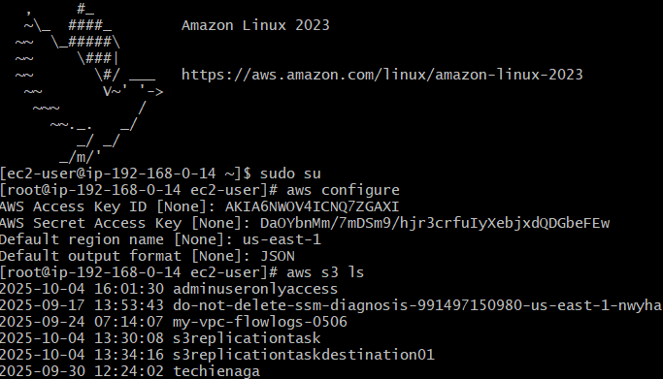
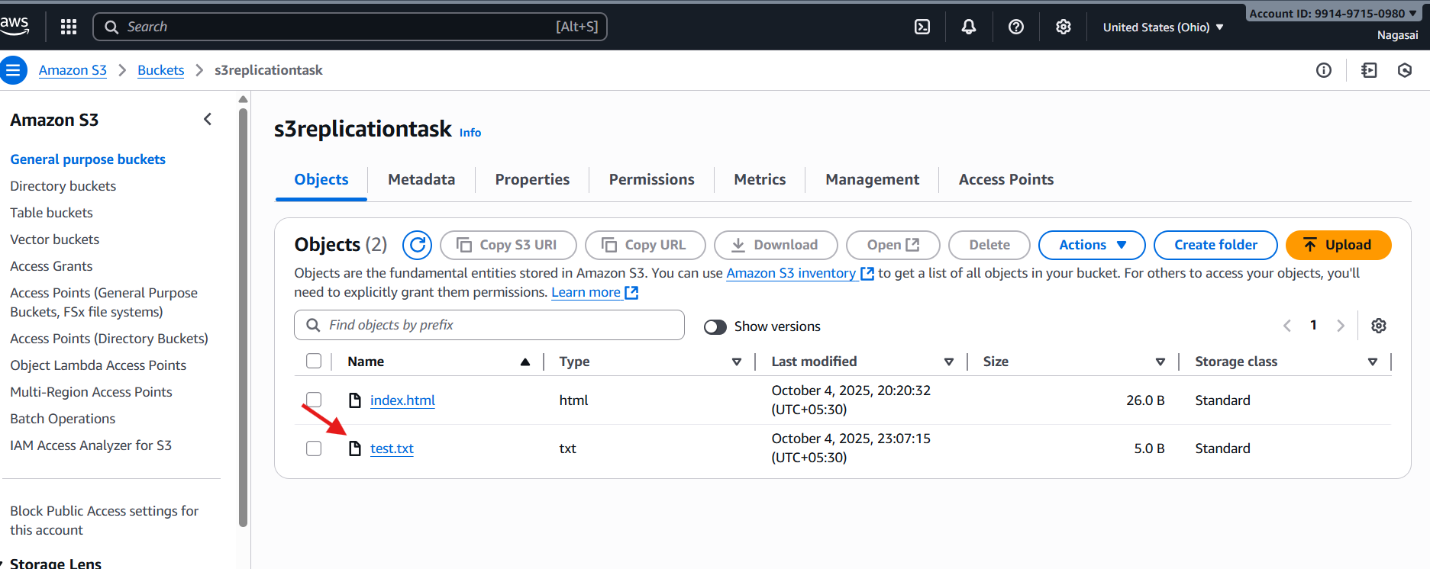

- Write a Bash script to create an S3 bucket.
#!/bin/bash
# ========= USER INPUTS =========
BUCKET_NAME="my-unique-bucket-20251001"
REGION="ap-south-1" # Example: Mumbai region
ACL="private" # Other options: public-read, private, etc.
# ================================
echo "Creating S3 bucket: $BUCKET_NAME in region: $REGION ..."
# Step 1: Create the bucket
if [ "$REGION" == "us-east-1" ]; then
# In us-east-1 you don't specify LocationConstraint
aws s3api create-bucket --bucket "$BUCKET_NAME" --acl "$ACL"
else
aws s3api create-bucket --bucket "$BUCKET_NAME" \
--region "$REGION" \
--create-bucket-configuration LocationConstraint="$REGION" \
--acl "$ACL"
fi
# Step 2: Enable block public access (recommended for security)
aws s3api put-public-access-block \
--bucket "$BUCKET_NAME" \
--public-access-block-configuration BlockPublicAcls=true,IgnorePublicAcls=true,BlockPublicPolicy=true,RestrictPublicBuckets=true
# Step 3: Verify bucket created
echo "Verifying bucket..."
aws s3 ls | grep "$BUCKET_NAME"
if [ $? -eq 0 ]; then
echo "✅ Bucket $BUCKET_NAME successfully created in $REGION."
else
echo "❌ Failed to create bucket."
fi

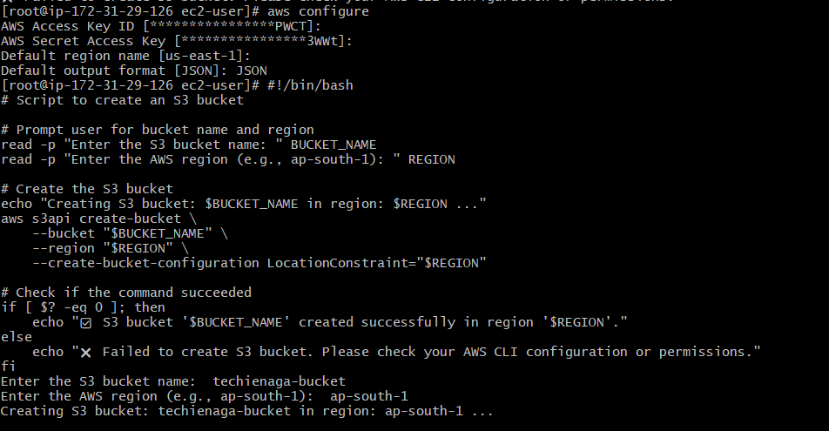
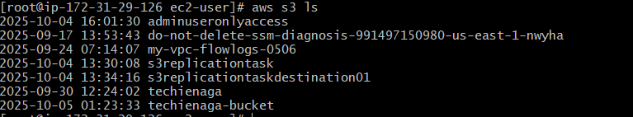
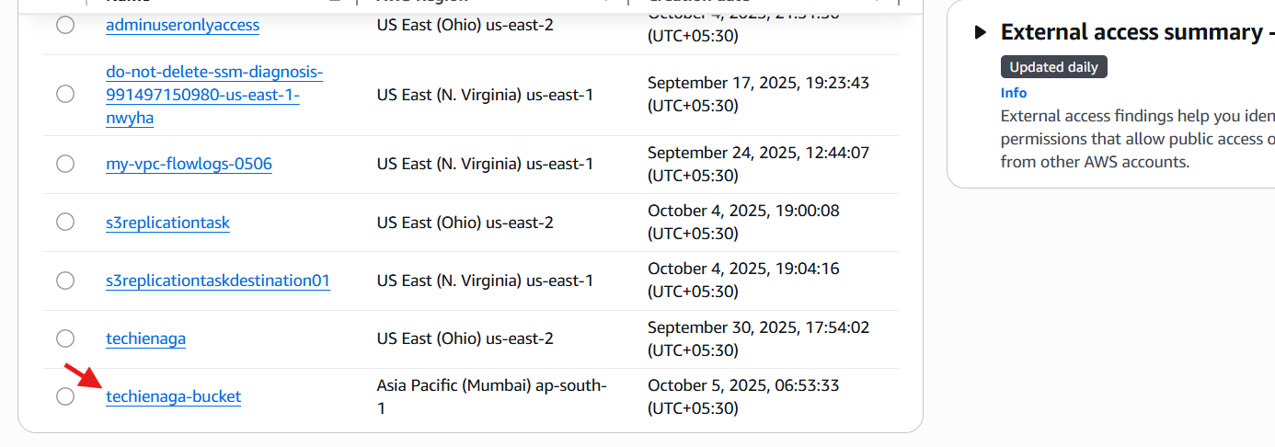

- Upload a 1 GB file to S3 using the CLI
¬Then using $ dd if=/dev/zero of=bigfile1GB.txt bs=1M
count=1024
¬this command is create a on dummy file for 1 gb
capacity.
¬Then check ur bucket list aws s3 ls.

